**cid:image001.png@01D8562F.4A1EBE10**

**Memorandum from the Department Of Facilities Management**

**TO:**Employees and Providers

**FROM:**Facilities Leadership

**DATE:** October 13, 2022

**SUBJECT:**Four Days to Entrance and Parking Reroutes

**FOUR DAYS TO REROUTES**

As a reminder, **effective Monday, October 17, 2022,** the Main Entrance and Emergency Entrance will be “flipping” to Cottage Street, and staff parking is being modified. Office/registration staff are reminded to share this information with all patients who have appointments on or after this coming Monday.

All staff are asked to make note of the four locations on the below map that are targeted for staff parking. Please refrain from parking in slots allocated for patients and visitors. A detailed map is available in the [**CPH Parking Procedures**](https://cphospital.policystat.com/policy/token_access/3fb4e1e5-1fc8-4576-a4cd-58fc7b32a9eb/) policy.

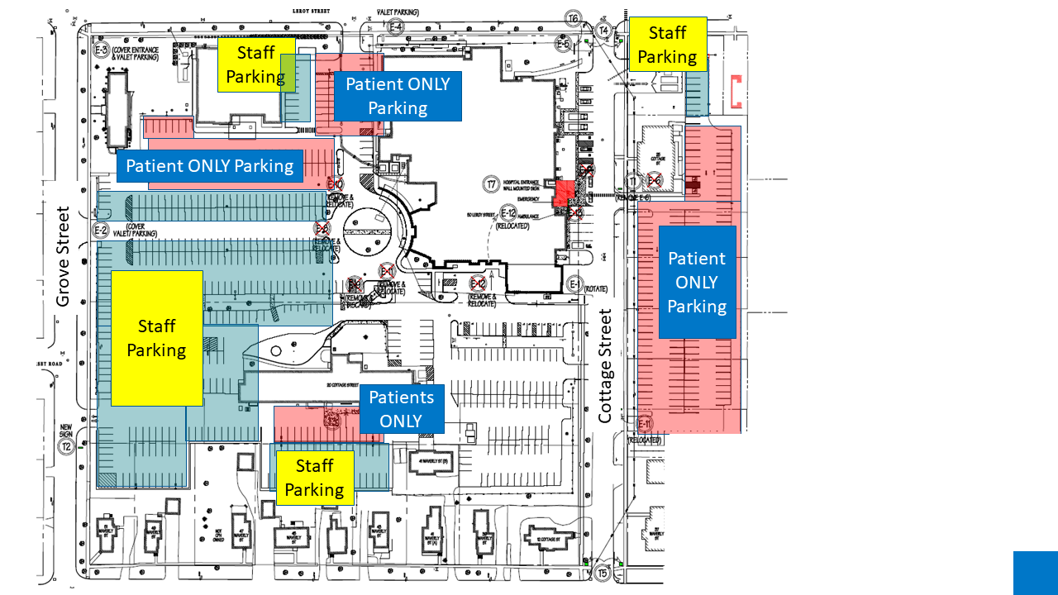

**HAVE PATIENCE WITH OUR PATIENTS**  
If patients are running late for an appointment located within the Hospital construction area, please be your helpful selves and assure them **their appointments will not be affected**. While staff members will be positioned throughout the parking lots, some patients may have to turn around and go in another direction to park in the proper lot.

**IMPORTANT REMINDERS**

* Staff will enter/exit the Hospital via the “med staff” door near the Cancer Center, or near the Dietary entrance off Cottage Street (both will be marked).
* The expected entrance flip to 20 Cottage Street’s **Behavioral Health services, and the Sleep Lab** is slated for Monday, October 24. Patients and visitors to these departments will be entering from the back side of the building, where new parking has been established.

**ADDITIONAL INFORMATION**

Please direct your questions or concerns to Director of Construction Management Jon Huckle at 315.212.6848, or Construction Project Manager Kristin Diamond at 315.212.2418.

Should you, members of our community, or perspective donors have further questions related to our expansion project, please direct them to email members of our project committee at [carepavilion@cphospital.org](mailto:carepavilion@cphospital.org).

The Care Pavilion web page may be found at [https://stlawrencehealthsystem.org/about/regional-care-pavilion](https://urldefense.proofpoint.com/v2/url?u=https-3A__linkprotect.cudasvc.com_url-3Fa-3Dhttps-253a-252f-252fstlawrencehealthsystem.org-252fabout-252fregional-2Dcare-2Dpavilion-26c-3DE-2C1-2CxmgKgKA9IvKTRokxgQBsDYDmfILaIMleew3urUmoHMdDIYxGRZuy-2DM-5F-5FIDeOTrs-2DW7EqDxN7tATIVe0a-5FVgVfMbzY8mAaU7PTevLd-5Fe5Mm4yw3vI-26typo-3D1&d=DwMFAw&c=ZcS_IThVDLRgSnibLQVJ9vwqRPpc3RkFqvJL1VfvJu0&r=LIbmuyWdGz-kTfgYuDc3duFs6ltTm3QuEwNftUIDzyw&m=2F10WhwLFLGJX-8wK-dOuF-qmUFIEzRycXgUSlSx9YCgzdnxC1V0QsZiWNMBVA34&s=0FbQtdRnufGbjLI_6S7Uxv84TMZ4Ca91pGvHTymOYbg&e=). The site provides updated photos and information about the project.