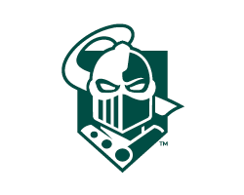

**2024 – 2025 REGULAR SEMESTER HOURS**

***Deneka Family Fitness Center &  
Indoor Recreation Center Hours***

**Monday – Friday** 6:00 a.m. – 11:00 p.m.  
**Saturday & Sunday** 10:00 a.m. – 11:00 p.m.

***Fuller Pool Hours – Updated 8/29/2024*Monday – Friday**  
8:00 a.m. – 9:00 a.m.  
11:30 a.m. – 1:00 p.m.  
**7:30 p.m. – 10:00 p.m.**  
**On Friday pool closes at 8:30 p.m.**  
**Saturday & Sunday**  
11:00 a.m. – 2:00 p.m.

If you have any questions please send an email to [fitnesscenter@clarkson.edu](mailto:fitnesscenter@clarkson.edu) or call 315-268-6622 or 315-268-7963.

**HOURS OF OPERATION WILL VARY DURING ACADEMIC BREAKS-**

Entrance with valid ID only, must have a change of athletic shoes and enter only during hours of operation.