The Institute for a Sustainable Environment presents
the inaugural lecture of the
ISE Clarkson Keynote Lecture Series*

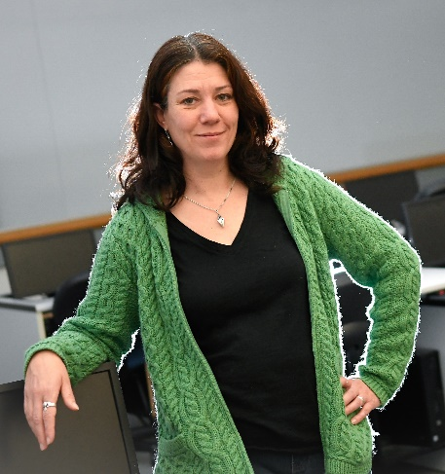
Simulated Farming: Enhanced Decision Making in Agricultural Regions with Modeling and Optimization

By Dr. Kathleen Kavanagh
Professor, Department of Mathematics, Clarkson University
Associate Director, Institute for STEM Education

3 pm January 24, 2019
Lecture is 3-4 pm, followed by a reception
Student Center Multipurpose Room ABC

Abstract:
Global industrialization, population growth, and large-scale agriculture means the demand for water is greater than ever. Simultaneously, urbanization is decreasing the amount of water which infiltrates back into the ground and fresh water aquifers are being depleted. Climate variability and its potential effects on the water system add to the growing concern in the future of the water supply. Water management agencies continually need to balance availability of resources against a variety of stakeholder needs.

Optimal management of both surface water and groundwater resources for agricultural irrigation can be approached using modeling and decision making tools. In recent work, simulation-based optimization has been applied to guide agricultural management decisions in the face of limited availability of water. This work is inherently interdisciplinary, requiring collaborations between hydrologists, farmers, mathematicians, economists, and sociologists. Moreover, it can be approached from multiple directions of varying complexity. We describe a suite of strategies for obtaining feasible solutions that potentially satisfy the often competing objectives of regional stakeholders.

Biography:
Katie Kavanagh is a professor in the department of mathematics, joining Clarkson in 2003 after getting her PhD in Computational Applied Mathematics at North Carolina State University. Her research has primarily focused on developing optimization algorithms and modeling approaches to design problems in engineering, with an emphasis on environmental applications. Her work on agricultural modeling has been featured on PBS Newshour and was chosen to represent the American Mathematical Society at the Coalition for National Science Funding’s Exhibition on Capital Hill in 2017. She is also the Associate Director of Clarkson's Institute for STEM Education and the Vice President for Education for the Society for Industrial and Applied Mathematics.
* The ISE Clarkson Keynote Lecture Series celebrates the achievements of the Clarkson faculty. Clarkson faculty are invited to deliver keynote and plenary lectures at conferences across the world. The ISE Clarkson Keynote Lecture Series honorees deliver these lectures to us at home, with modifications for a broader audience.
If you are interested in nominating someone, including yourself, for the ISE Clarkson Keynote Lecture Series, please send an email to ise@clarkson.edu with the following information: name, department, lecture title, lecture abstract, and conference information for which the keynote lecture was delivered (e.g., a link to the conference page advertising the keynote/plenary lecture). The topic should be in the broad area of sustainability and the environment.

