Clarkson University
Spring 2024 David A. Walsh‘67
Arts & Sciences Seminar Series
Friday, March 29 at 12pm
Room: Snell 212

OPPORTUNITIES FOR UNDERREPRESENTED STEM MAJORS THROUGH THE EXPERIENCE OF A
CARIBBEAN-AMERICAN
There are a variety of possibilities for students of color to do research, study STEM majors, and pursue higher education. However, less than 35% of minority people have earned a college degree. Furthermore, only 18% hold a STEM degree. While there are many factors that contribute to this gap, one of the main reasons is due to lack of specialized support for students of color. However, one common anomaly is the lack of awareness of the support services provided by their schools. It wasn't until my junior year of college that I learned about the research options available to students at my school, as well as opportunities to attend conferences. Taking advantage of these possibilities during my early undergraduate years would have helped me develop a stronger resume and introduced me to more professional opportunities. Clarkson University does an excellent job of advertising the support services it offers, yet it is nevertheless surprising how few students are aware of these options or just do not take advantage of them.

Pathea Bruno, Ph.D. Student, Biochemistry & Proteomics Laboratories, Department of Chemistry and Biochemistry
Pathea is a graduate student pursuing a PhD in chemistry at Clarkson University in the department of Chemistry and Biochemistry. She graduated with a Bachelor of Science in Biology in 2021 from Iona College in New Rochelle, NY. Her research focuses on identifying peptide sequences and metabolites from human breast milk and serum using mass spectrometry as a means of identifying a biomarker for early detection of breast cancer in women of all ages. Her work is supported through a NIH Minority Supplement to a R15 Academic Research Enhancement Award.

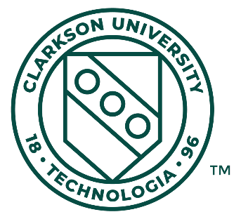
The Arts & Sciences Seminar Series is a weekly colloquium series that has been supported by the School of Arts & Sciences Advisory Council at Clarkson University especially through generous gifts from David A. Walsh ‘67.
SA&S 300: Arts and Sciences Seminar is a one credit course intended to foster an
interdisciplinary outlook in undergraduates majoring in the School of Arts and Sciences.

