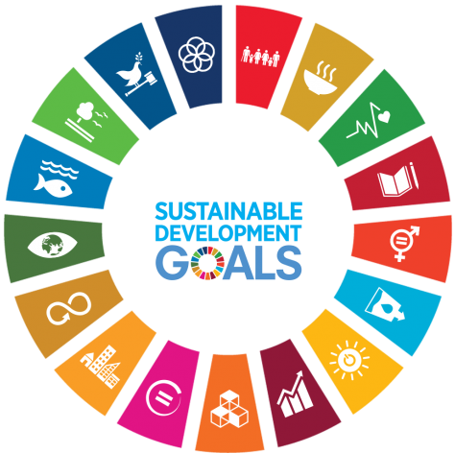
Part 1: Faculty Workshop
SDG Blitz - Workshop on the integration of Sustainable Dev. Goals (SDGs) in your courses and curricula
Feb 24, 10-11:30am, Snell Petersen Board Room or Zoom (in person suggested if possible)

Sustainability in All We Do - this operating principle of the strategic framework promotes the integration of sustainability concepts across all of our curricula. Let's graduate students with the capacity and attitudes necessary to tackle our world's wicked problems.
Please join us for the hybrid zoom/in-person workshop for an intro presentation about the SDGs in higher ed, hear from your peers, and workshop time to work with your colleagues. By attending this workshop you will...
* understand the value for integrating SDGs into our courses and curricula to prepare our students for their future
* identify the alignment of SDGs with what you currently teach and opportunities for new or modified classes (there will be a call for proposals for small faculty development grants)
* gain access to resources for SDG in your classes and stated learning objectives
* build your network of like-minded colleagues from across campus
* become a leader in your department to support this initiative
PLEASE share your interest in attending through this very short google form

Part 2: Volunteers needed for SDG Blitz!

Have you ever wondered how sustainability is integrated into the classes you take for your degree? This is your opportunity to ask and learn. Volunteers needed to ask your instructors how they integrate the United Nations Sustainable Development Goals in their classes and scholarly work. We need volunteers representing all departments, Grad/Undergrad and campuses.

﻿GOAL - Identify all classes with sustainability content during the week of Feb. 24
Volunteer commitment - attend a 30 min training session. Commit to 5-10 min interviews with 8-10 instructors, complete a google form for each interview.
Live ZOOM Training sessions Feb 28 (12:30 or 5) and Mar 1(noon) will include an introduction to the SDGs and time for a practice interview skills.

PLEASE share your interest in volunteering through this very short google form

